**Started again from scratch:**

**===========================**

C:\XpressRules\Python\OpenShift\XpressRules Apps\ClinicalTrials_AWS>eb terminate --all

The application "ClinicalTrials_AWS" and all its resources will be deleted.

This application currently has the following:

Running environments: 2

Configuration templates: 0

Application versions: 13

To confirm, type the application name: ClinicalTrials_AWS

Removing application versions from s3.

INFO: deleteApplication is starting.

INFO: Invoking Environment Termination workflows.

INFO: The environment termination step is done.

INFO: The application has been deleted successfully.

C:\XpressRules\Python\OpenShift\XpressRules Apps\ClinicalTrials_AWS>eb list

ERROR: This directory has not been set up with the EB CLI

You must first run "eb init".

C:\XpressRules\Python\OpenShift\XpressRules Apps\ClinicalTrials_AWS>eb init

Select a default region

1) us-east-1 : US East (N. Virginia)

2) us-west-1 : US West (N. California)

3) us-west-2 : US West (Oregon)

4) eu-west-1 : EU (Ireland)

5) eu-central-1 : EU (Frankfurt)

6) ap-south-1 : Asia Pacific (Mumbai)

7) ap-southeast-1 : Asia Pacific (Singapore)

8) ap-southeast-2 : Asia Pacific (Sydney)

9) ap-northeast-1 : Asia Pacific (Tokyo)

10) ap-northeast-2 : Asia Pacific (Seoul)

11) sa-east-1 : South America (Sao Paulo)

12) cn-north-1 : China (Beijing)

13) us-east-2 : US East (Ohio)

14) ca-central-1 : Canada (Central)

15) eu-west-2 : EU (London)

(default is 3): 3

Select an application to use

1) django-tutorial

2) [ Create new Application ]

(default is 2):

Enter Application Name

(default is "ClinicalTrials_AWS"):

Application ClinicalTrials_AWS has been created.

It appears you are using Python. Is this correct?

(Y/n): Y

Select a platform version.

1) Python 3.6

2) Python 3.4

3) Python

4) Python 2.7

5) Python 3.4 (Preconfigured - Docker)

(default is 1):

Note: Elastic Beanstalk now supports AWS CodeCommit; a fully-managed source control service. To learn more, see Docs: https://aws.amazon.com/code

commit/

Do you wish to continue with CodeCommit? (y/N) (default is n):

Do you want to set up SSH for your instances?

(Y/n): Y

Select a keypair.

1) 09DecKeyPair

2) 10Dec17KeyPair

3) AWS-KeyPair

4) ronskey

5) [ Create new KeyPair ]

(default is 4): 2

C:\XpressRules\Python\OpenShift\XpressRules Apps\ClinicalTrials_AWS>eb create ClinicalTrials

WARNING: You have uncommitted changes.

Creating application version archive "app-354c-171216_175416".

Uploading: [##################################################] 100% Done...

Environment details for: ClinicalTrials

Application name: ClinicalTrials_AWS

Region: us-west-2

Deployed Version: app-354c-171216_175416

Environment ID: e-5pci73p2yp

Platform: arn:aws:elasticbeanstalk:us-west-2::platform/Python 3.6 running on 64bit Amazon Linux/2.6.0

Tier: WebServer-Standard-1.0

CNAME: UNKNOWN

Updated: 2017-12-17 01:55:42.891000+00:00

Printing Status:

INFO: createEnvironment is starting.

INFO: Using elasticbeanstalk-us-west-2-596452634722 as Amazon S3 storage bucket for environment data.

INFO: Created load balancer named: awseb-e-5-AWSEBLoa-1AJF0V0M7AT3D

INFO: Created security group named: awseb-e-5pci73p2yp-stack-AWSEBSecurityGroup-161X2FVCKB8VA

INFO: Created Auto Scaling launch configuration named: awseb-e-5pci73p2yp-stack-AWSEBAutoScalingLaunchConfiguration-A6IXM0ATPRIR

INFO: Created Auto Scaling group named: awseb-e-5pci73p2yp-stack-AWSEBAutoScalingGroup-13TGJCL8H2TJT

INFO: Waiting for EC2 instances to launch. This may take a few minutes.

INFO: Created Auto Scaling group policy named: arn:aws:autoscaling:us-west-2:596452634722:scalingPolicy:6b484e5e-2133-4bf9-8c6d-e3e33731afdf:auto

ScalingGroupName/awseb-e-5pci73p2yp-stack-AWSEBAutoScalingGroup-13TGJCL8H2TJT:policyName/awseb-e-5pci73p2yp-stack-AWSEBAutoScalingScaleUpPolicy-1

N7MN4CN5VZA7

INFO: Created Auto Scaling group policy named: arn:aws:autoscaling:us-west-2:596452634722:scalingPolicy:c29e4a98-225b-4aab-877e-d1f9c57d22c8:auto

ScalingGroupName/awseb-e-5pci73p2yp-stack-AWSEBAutoScalingGroup-13TGJCL8H2TJT:policyName/awseb-e-5pci73p2yp-stack-AWSEBAutoScalingScaleDownPolicy

-K78KDD8X87BC

INFO: Created CloudWatch alarm named: awseb-e-5pci73p2yp-stack-AWSEBCloudwatchAlarmHigh-15INO8B2GW0BS

INFO: Created CloudWatch alarm named: awseb-e-5pci73p2yp-stack-AWSEBCloudwatchAlarmLow-OOIP38JMJX14

ERROR: Your WSGIPath refers to a file that does not exist.

INFO: Successfully launched environment: ClinicalTrials

C:\XpressRules\Python\OpenShift\XpressRules Apps\ClinicalTrials_AWS>

**Identical error reported through console:**

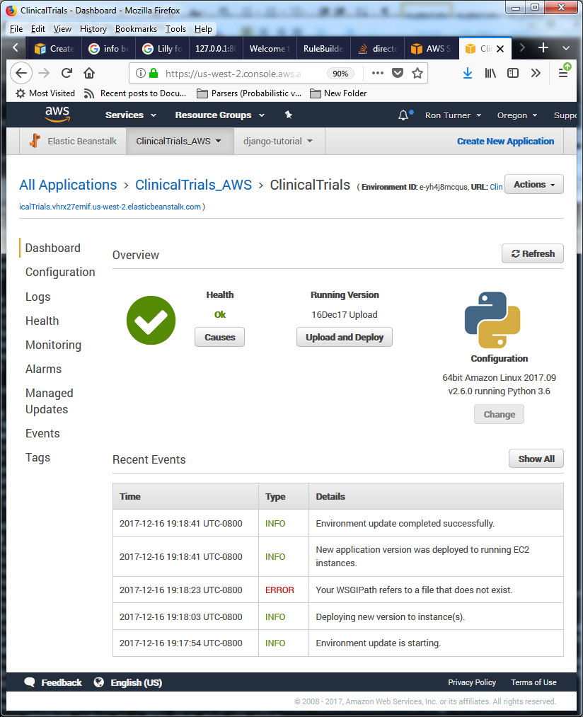

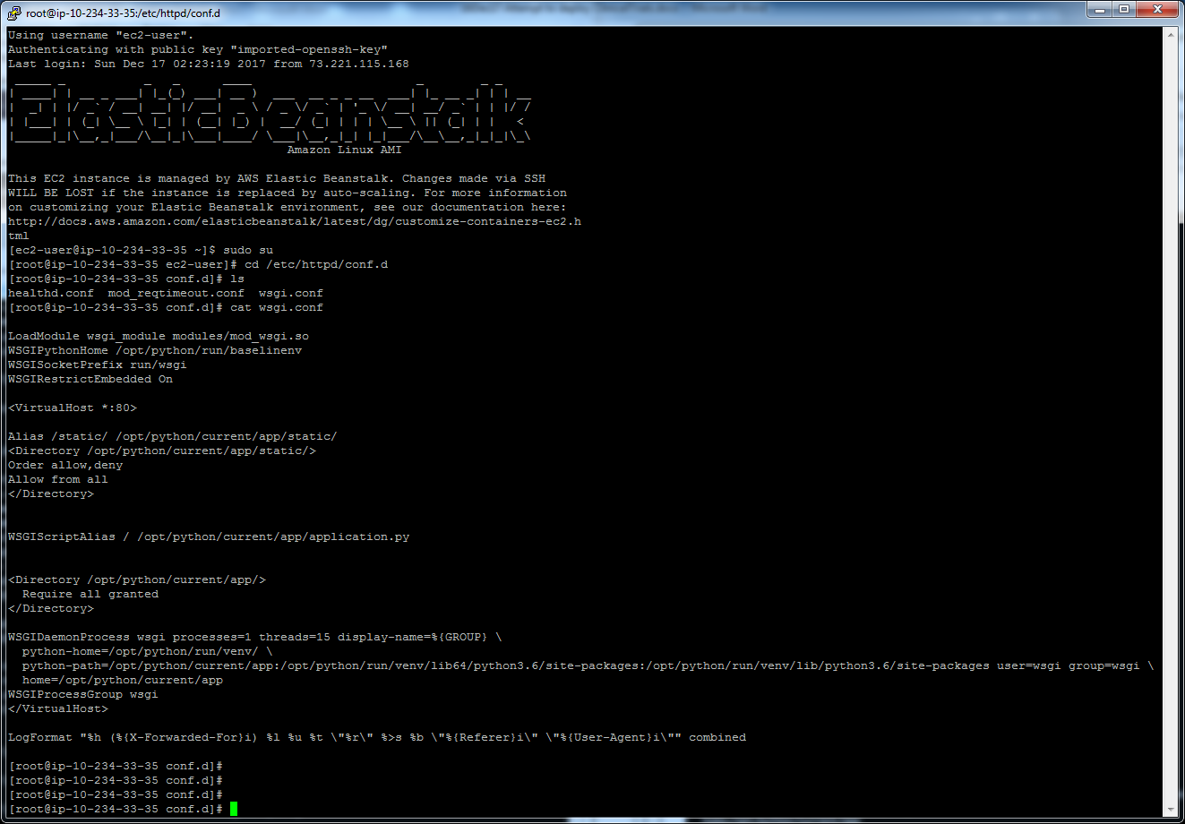

**Furthermore there is no /ebdjango (which there is in the source directory and its .zip):**

[root@ip-10-88-145-76 app]#

[root@ip-10-88-145-76 app]# pwd

/opt/python/current/app

[root@ip-10-88-145-76 app]# ls

05Jul16 correction notes with files changes.txt

13May16 Migration revisions for Subordinated (parallel) demos.docx

ABAC_Studio.html

ABAC_Studio-LOCAL.html

buildPolicies

BuildPolicyConsole

compile

Crib Sheet For Running XLATE conversions.docx

db.sqlite3

Dev-Completion notes for dot-net to Cloud.docx

django.db.backends.sqlite3

editRule

git

InfoTypes.xml

__init__.py

JSON-BusRules

manage.py

~$May16 Migration revisions for Subordinated (parallel) demos.docx

Multi-Demo Revision Notes (13May16).txt

Pip-list.txt

__pycache__

Release Notes.txt

requirements.txt

SentenceLayoutDefinition-ABAC-eTMF-SAFE (copy).csv

SentenceLayoutDefinition-ABAC-eTMF-SAFE.csv

settings.py

settings.pyc

setup-EDITED.py

setup.py

stable-req.txt

StartServer.bat

tree.txt

Tree View of Sylvia Project.odt

urls-NEW.py

urls.py

urls.pyc

Welcome to the ABAC Policy Studio.htm

Welcome to the ABAC Policy Studio-LOCAL.htm

wsgi-127-DISPATCH.py

wsgi-CUSTOM.py

wsgi.py

wsgi.pyc

wsgi-STOCK.py

XACMLstore

xlate

xlatePhantom.txt

[root@ip-10-88-145-76 app]# ls /ebdjango

ls: cannot access /ebdjango: No such file or directory

[root@ip-10-88-145-76 app]#

**Contents of C:\XpressRules\Python\OpenShift\XpressRules Apps\ClinicalTrials_AWS\.ebextensions\django.conf:**

option_settings:

aws:elasticbeanstalk:container:python:

WSGIPath: ebdjango/wsgi.py